Task 1:
Steps:
- Login to site as user customer0, password compass0
- Click the account icon and under this click credit cards
- Open the network tab in developer tools, here you will see a call for /api/creditcard/account
- Resend the request and change the number of the request in the http address field of the session token. Ex instead of a request send to /api/creditcard/account/5aa0481e876d9d39d4397859, try sending it to /api/creditcard/account/5aa0481e876d9d39d4397862.
- You will then see returned in json format the credit card number of the user requested.
- This can happen due to incorrect permissions and no token authentication, meaning anyone can access these calls regardless of the user status. There is also no limit of how many calls you can make, so you can try as many times as needed until you find a credit card number.
- URL:
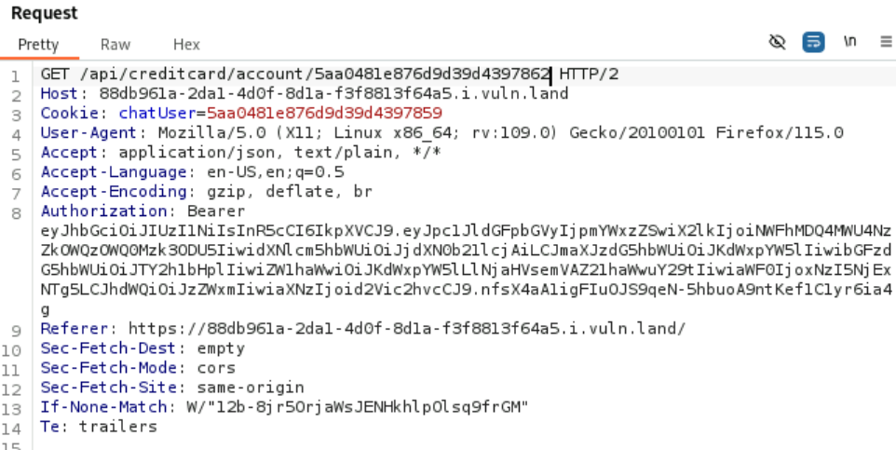
- Credit Card Number:
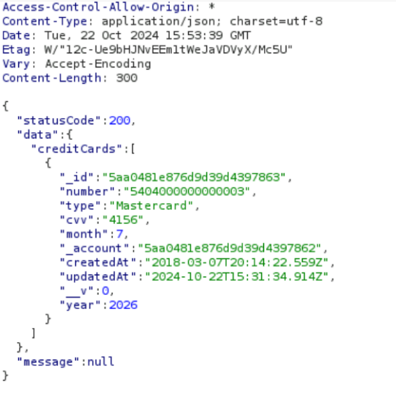
Task1:

- Log in as customer0 and go to credit card and click on edit
- You will get this url: https://084008af-8153-460e-8ac0-7c95f7401566.i.vuln.land/#!/creditcard/5404000000000001
- 5404000000000001 is the creditcard number of customer0
- Increase the number by 1: https://084008af-8153-460e-8ac0-7c95f7401566.i.vuln.land/#!/creditcard/5404000000000002 and you will get this:
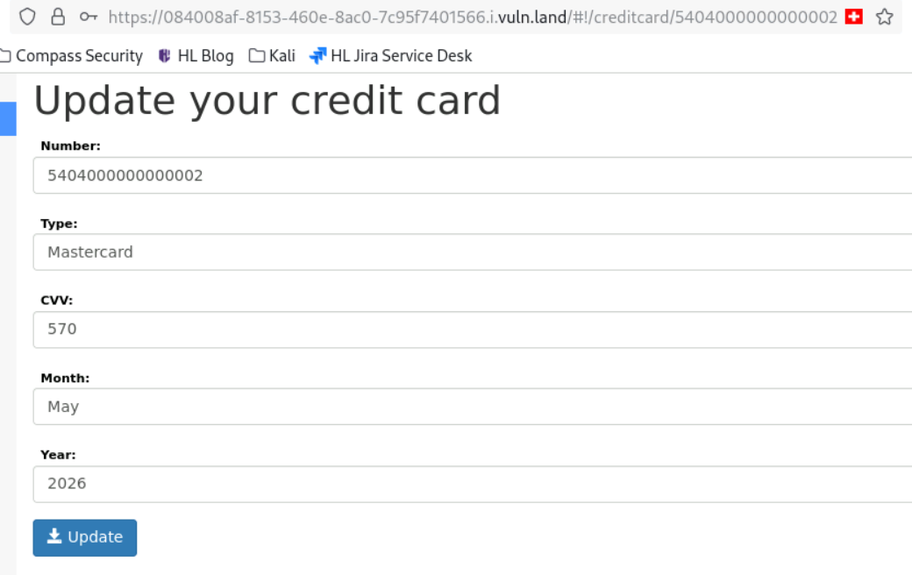
The vulnerability is in the url. This is an Object Level Access Problem. User has right to something which he shouldn’t have. He can get all the credit card informations of all customers by just manipulating the url.

Task 2:
- Start Burp
- Log in as random user with random password
- Put a random note and click on the plus symbol
- Go to Burp and select “GET”, “/api/get_notes”
- You can see the vulnerability -> user_id = 1417
- Send this to Intruder
- Mark the number and click on ADD, Should be looking like this: §1417§
- Go to payloads and set the payload type to “Numbers” and select the range between 0 and 1000 and step 1!
- Start the attack and wait until the length of one number is different from the others!
The solution is number 83!
- Send “GET”, “/api/get_notes” to repeater and change the user_id to 83:
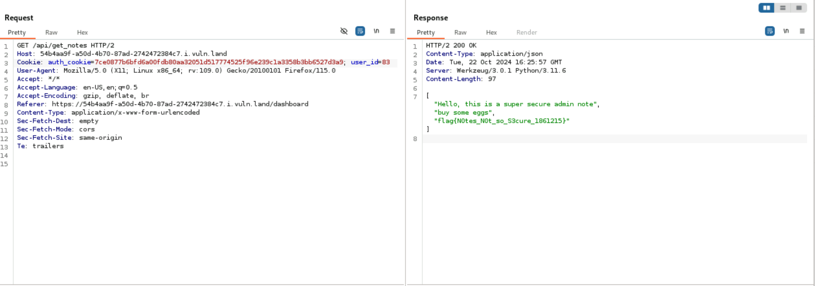
The Flag: flag{N0tes_N0t_so_S3cure_1861215}

Task 3:
- Log in as customer 0 and go to orders. Start Burp!
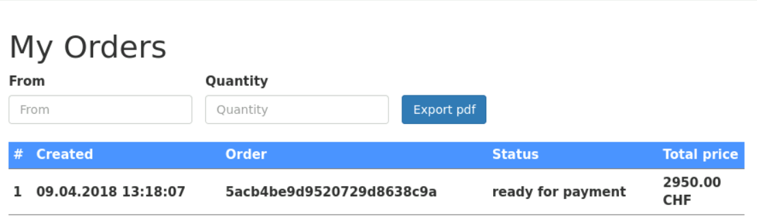
- In Burp, you can see this:
“GET /api/order/account/…”
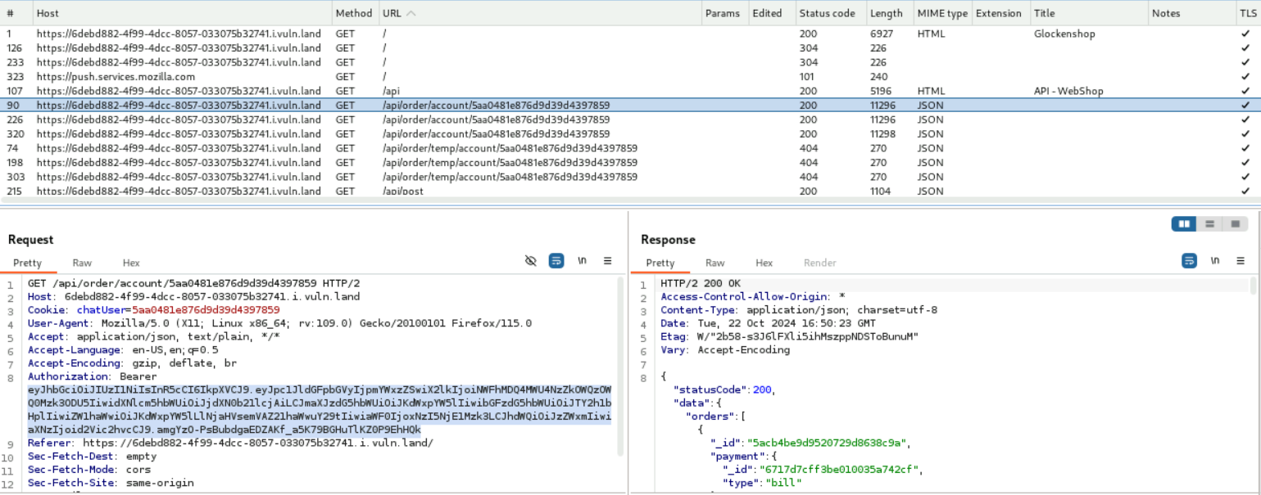
- Send this Json to Repeater!
- Go to a browser and type in: https://6debd882-4f99-4dcc-8057-033075b32741.i.vuln.land/api
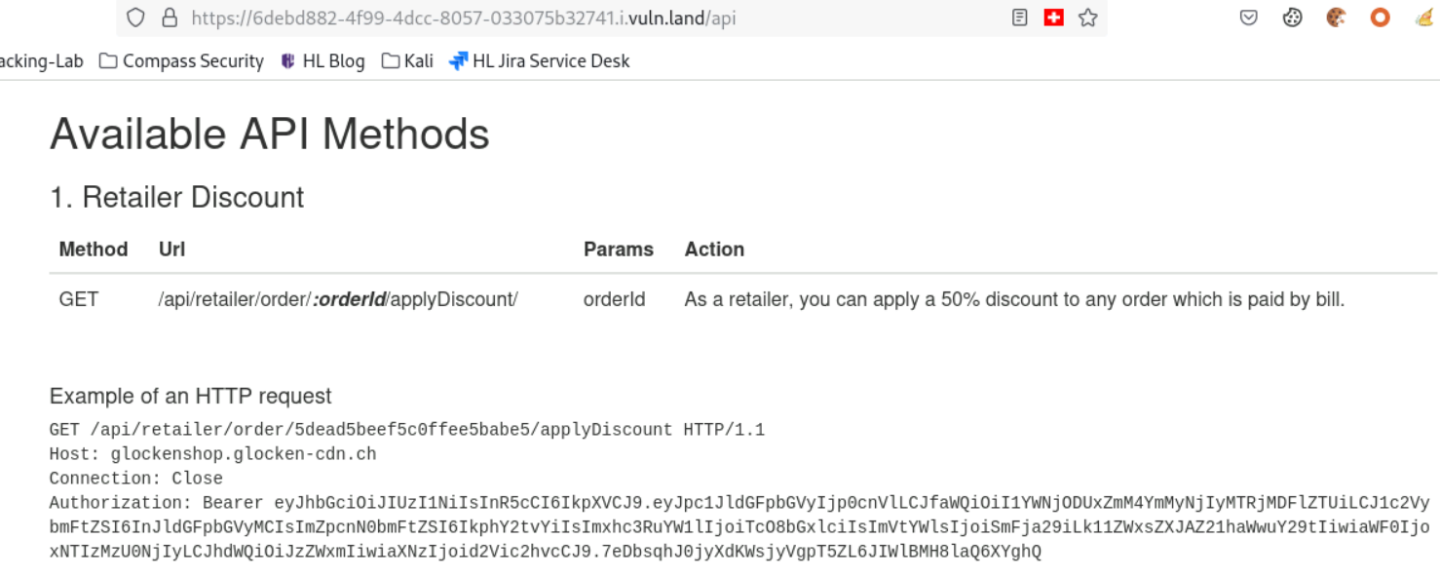
Copy GET /api/retailer/order/:orderID/applyDiscount/ and Authorization: Bearer…
- 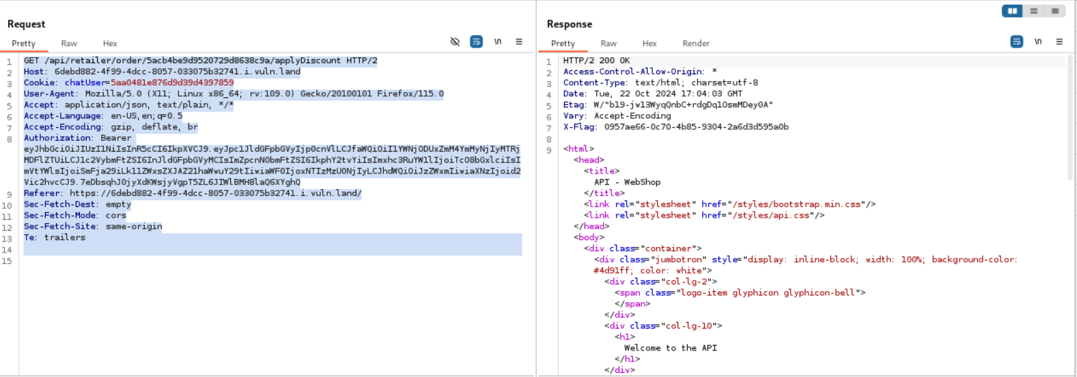
Replace the first line with the Retailer API Call and the line 8 with the Authorization!
Important! Replace in the Retailer API Call the orderID with the correct OrderId from customer0. This can be found on the webpage:
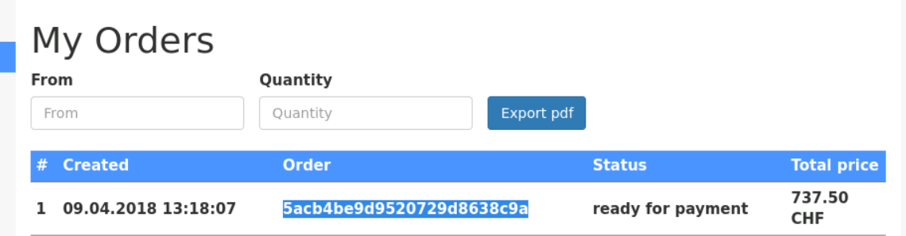
We can see, that the total price is reduced!

Task 4:

- Log in as Alice start burp
- Go to community
- In Burp you see the json command: /api/users, there are all users with all uid
- Got to the address area and type in: https://b006481a-3f47-4005-9423-363c90d2de1e.i.vuln.land/api/user/102
- You get alle the information from the user Bob with the hashed password!
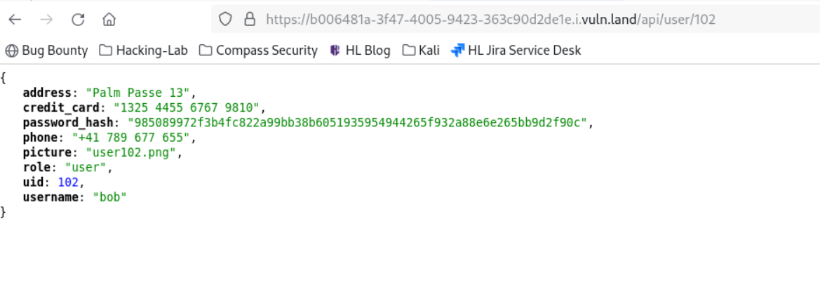
- Create the file “hashes.txt” and write: 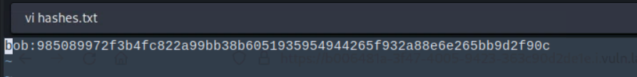
- download the 10millionpassword from github
- in the command line execute:
john hashes.txt --format=raw-sha256 --wordlist=10millionpasswords.txt --rules=all
- Wait 30 minutes and you get: 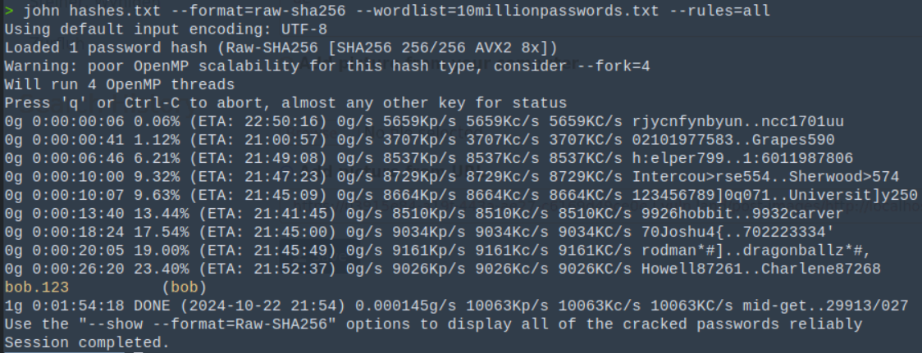

Task 5:

- Log in as customer0 and go to Home!
- There is an unload picture with the title “Awesome product”
If you click on the image, the picture is not available.
This is the url of this image: https://a5ee1462-cd85-48ca-9767-ba452b40b1cf.i.vuln.land/post-images/http://localhost:8765/file001.jpg
- Go to community and try to upload the image from url!
It doesn’t work!
- There is a problem with the ip!
Try this:
http://127.0.0.1:8765/file001.jpg

This works because, 127.0.0.1 is the ip from localhoast!
Finally try this to get the passwords: http://127.0.0.1:8765/file002.jpg
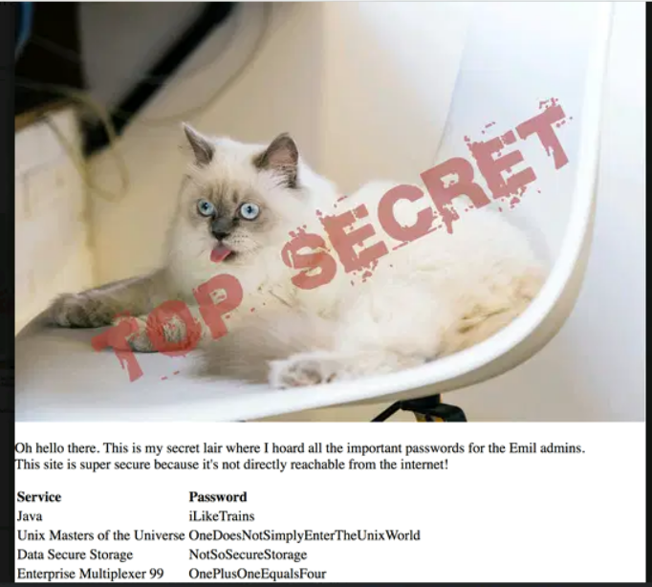
Task 6:
- Execute this command with the url of Historia Animalium Webpage.
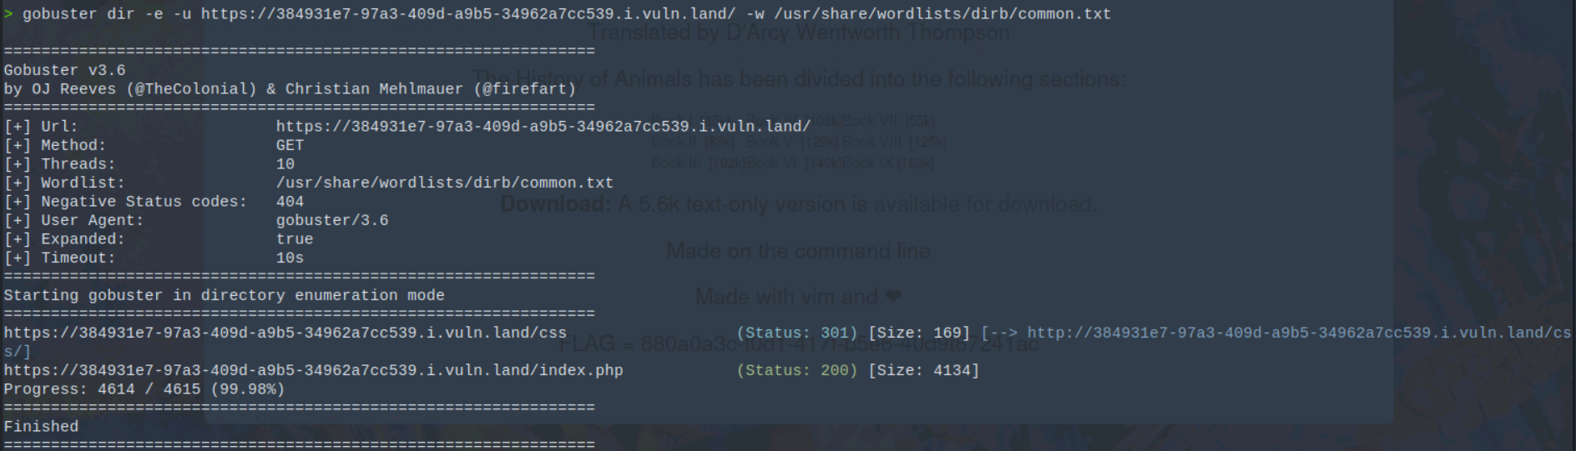
Homepage resource file: index.php
- 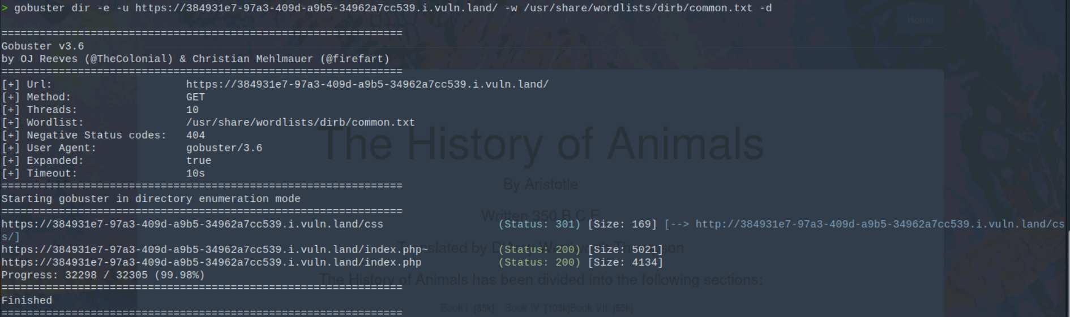
backup file: index.php~
Save this!
- vi index.php~:
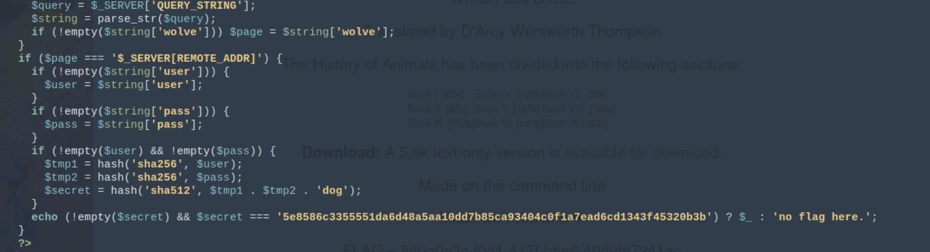
The vulnerability is in string = parse_str($query); This is deprecated. It should also have result in the parameter. Because of this, you can set the if statements, “page = $_SERVER[REMOTE_ADDR]” and “$secret = 5e8586c3355551da6d48a5aa10dd7b85ca93404c0f1a7ead6cd1343f45320b3b” true!
- To get the flag:
URL: https://384931e7-97a3-409d-a9b5-34962a7cc539.i.vuln.land/?page=$_SERVER[REMOTE_ADDR]&secret=5e8586c3355551da6d48a5aa10dd7b85ca93404c0f1a7ead6cd1343f45320b3b
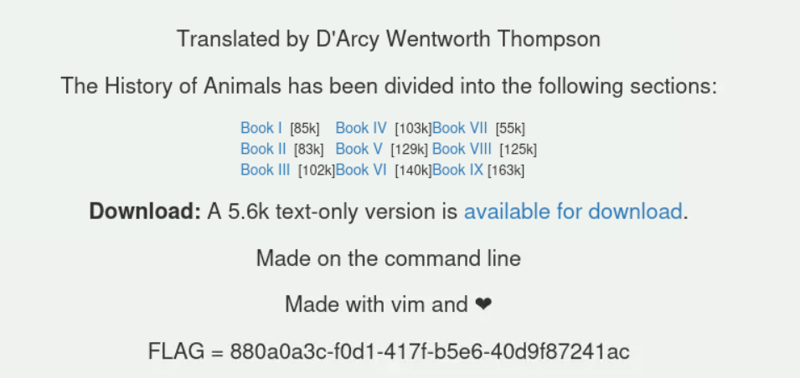
FLAG = 880a0a3c-f0d1-417f-b5e6-40d9f87241ac

